WindowsXP
Disabling the System Restore Utility (Windows XP Users)
1. Right click the My Computer icon on the Desktop and click on Properties.
2. Click on the System Restore tab.
3. Put a check mark next to 'Turn off System Restore on All Drives'.
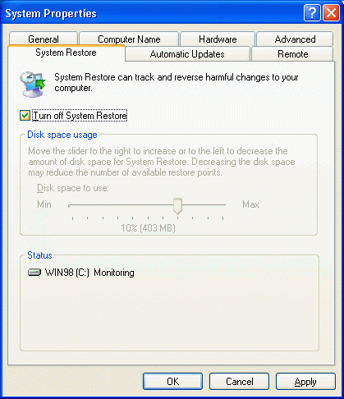
4. Click the 'OK' button.
5. You will be prompted to restart the computer. Click Yes.
Note: To re-enable the Restore Utility, follow steps one to five and on step three remove the check mark next to 'Turn off System Restore on All Drives'.

