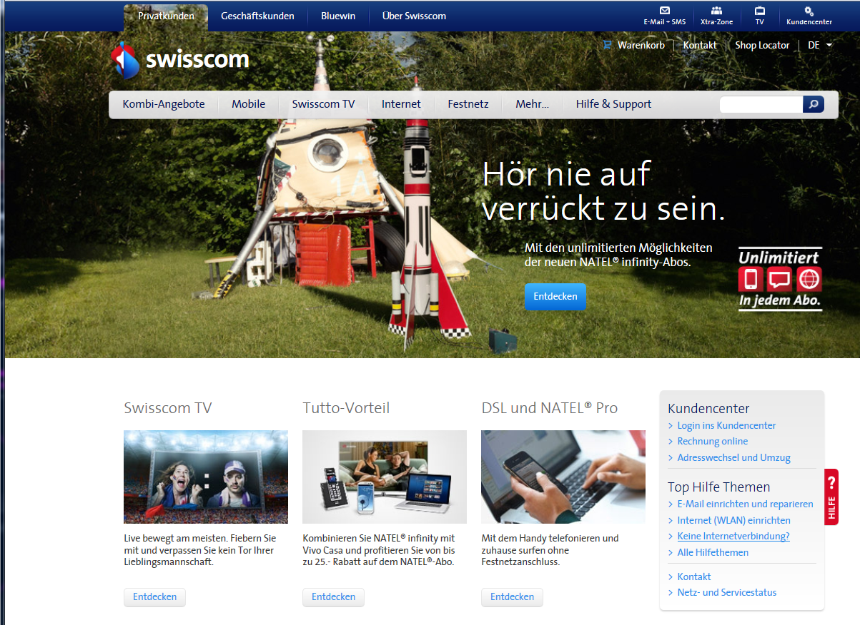

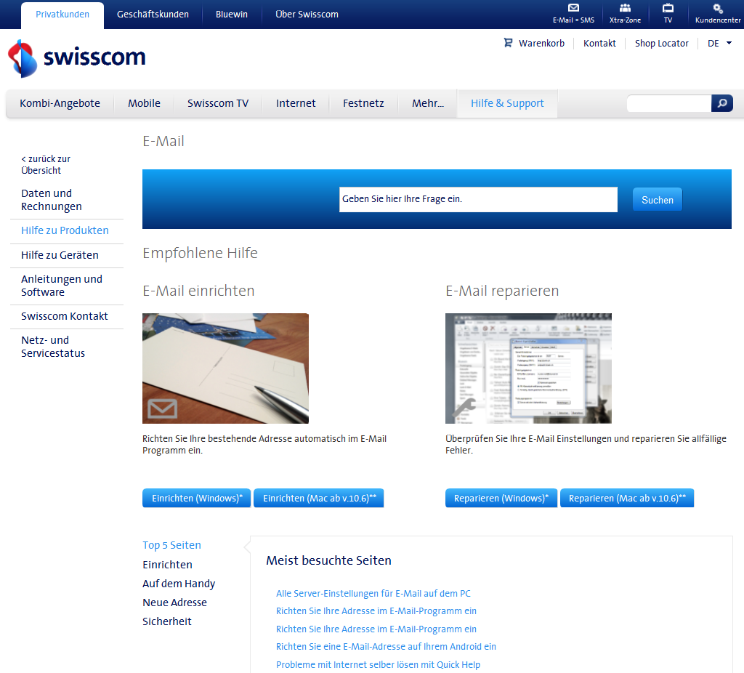

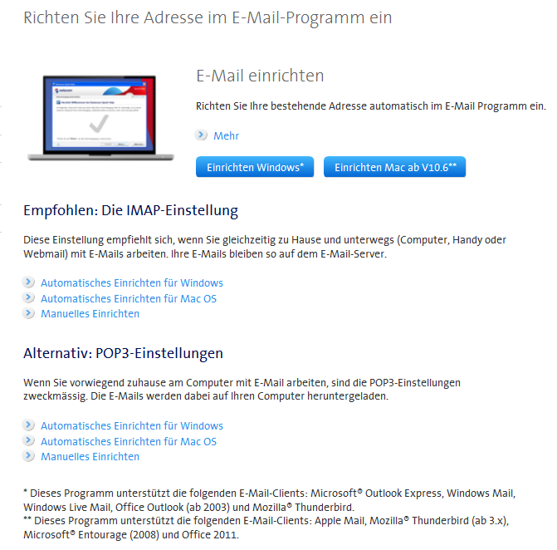

https://www.swisscom.ch/content/dam/swisscom/nl/res/hilfe/downloadcenter/internet/Tools/SwisscomEmailCreate_pop.exe