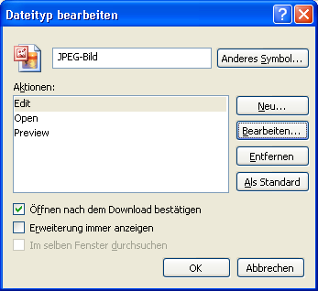
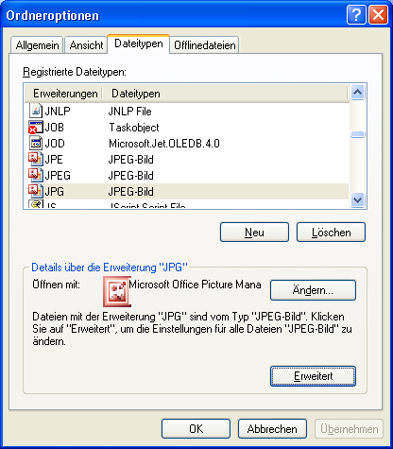

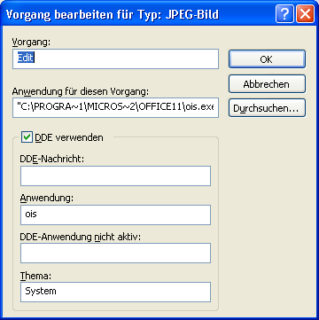
"C:\PROGRA~1\MICROS~2\OFFICE11\ois.exe" /shellEdit "%1"

Open "C:\PROGRA~1\MICROS~2\OFFICE11\ois.exe" /shellOpen "%1"
Preview "C:\PROGRA~1\MICROS~2\OFFICE11\ois.exe" /shellOpen "%1"

