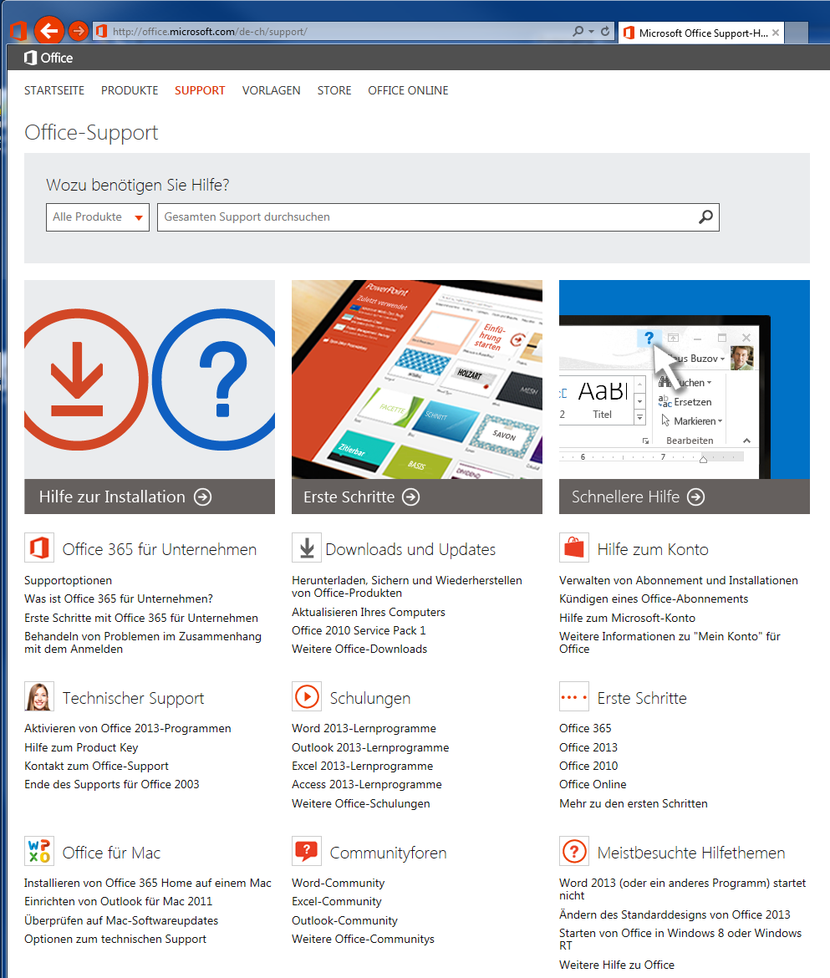

http://office.microsoft.com/de-ch/support/

